W

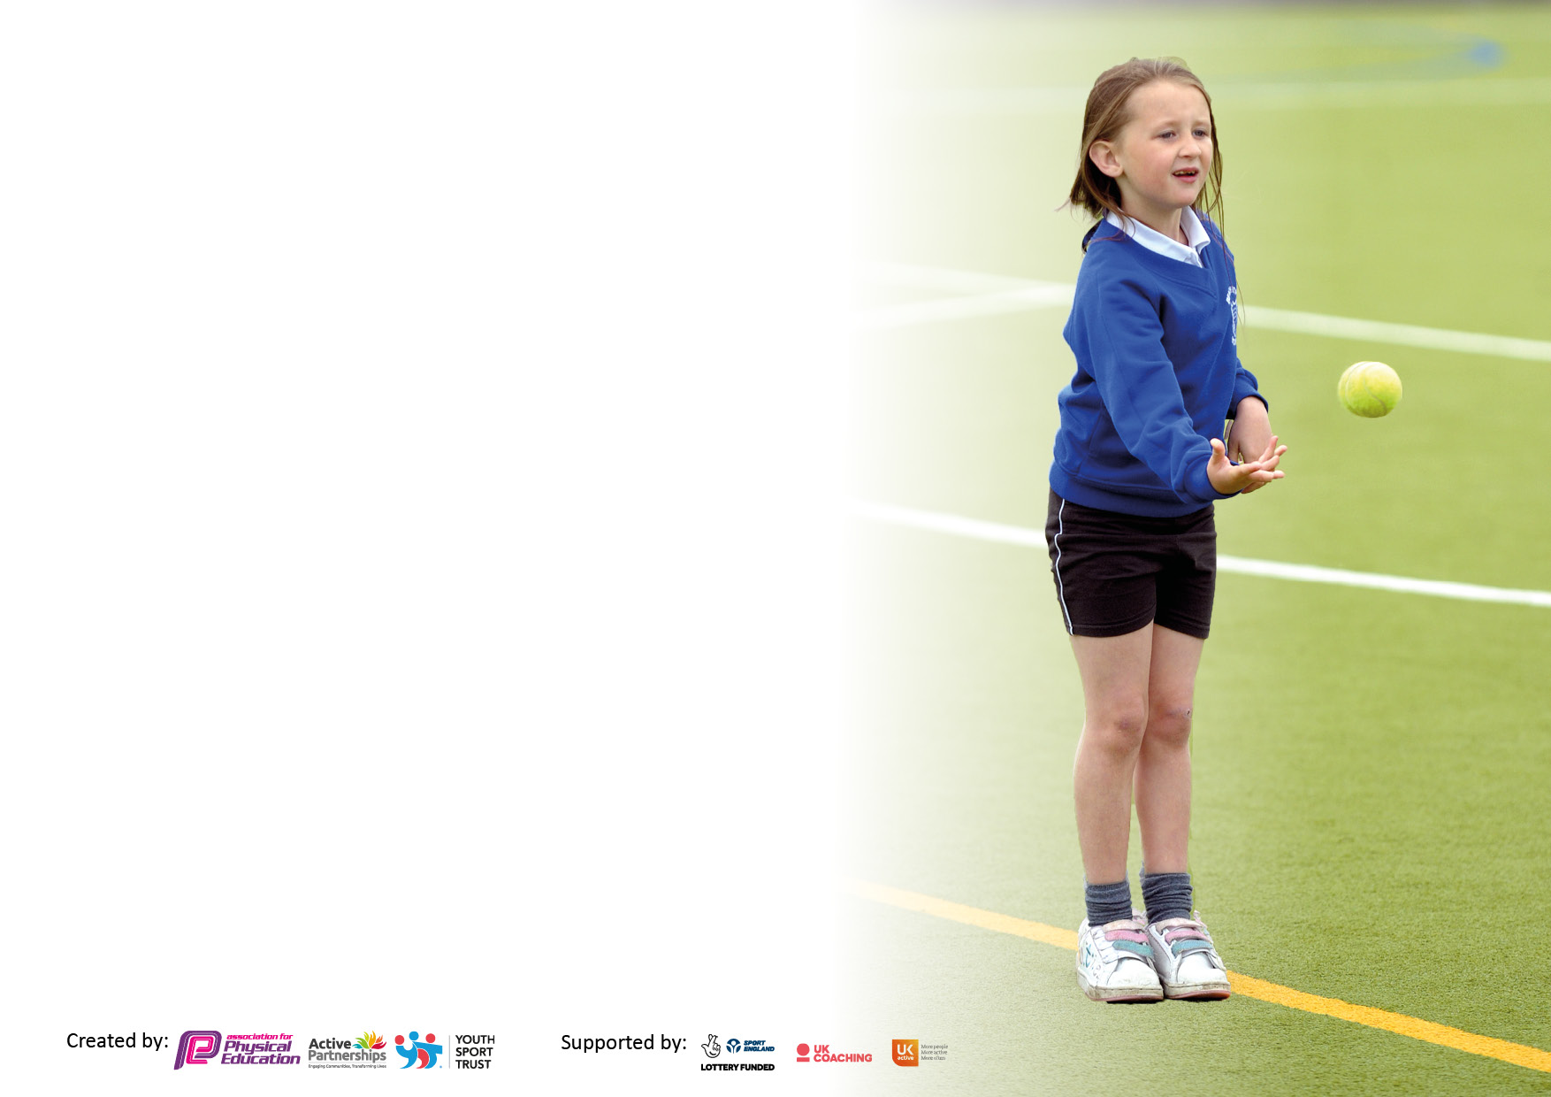

It is important that your grant is used effectively and based on school need. The [Education Inspection Framework](https://www.gov.uk/government/publications/education-inspection-framework) makes clear there will be a focus on **‘whether leaders and those responsible for governors all understand their respective roles and perform these in a way that enhances the effectiveness of the school’**.

Under the Quality of Education judgement, Ofsted inspectors consider:

**Intent** - Curriculum design, coverage and appropriateness

**Implementation** - Curriculum delivery, teaching (pedagogy) and assessment

**Impact** - Attainment and progress

To assist schools with common transferable language, this template has been developed to utilise the same three headings which should make your plans easily transferable between working documents.

Schools must use the funding to make additional and sustainable improvements to the quality of Physical Education, School Sport and Physical Activity (PESSPA) they offer. This means that you should use the Primary PE and sport premium to:

* Develop or add to the PESSPA activities that your school already offers
* Build capacity and capability within the school to ensure that improvements made now will benefit pupils joining the school in future years
* The Primary PE and sport premium should not be used to fund capital spend projects; the school’s budget should fund these.

Please visit <https://www.gov.uk/guidance/pe-and-sport-premium-for-primary-schools> for the revised DfE guidance, including the 5 key indicators across which schools should demonstrate an improvement. This document will help you to review your provision and to report your spend. DfE encourages schools to use this template as an effective way of meeting the reporting requirements of the Primary PE and Sport Premium.

We recommend you start by reflecting on the impact of current provision and reviewing the previous spend.

Schools are required to publish details of how they spend this funding, including any underspend from 2021/2022, as well as on the impact it has on pupils’ PE and sport participation and attainment.

We recommend regularly updating the table and publishing it on your website throughout the year. This evidences your ongoing self-evaluation of how you are using the funding to secure maximum, sustainable impact. Final copy must be posted on your website by the end of the academic year and no later than the 31 July 2023.



**Evidencing the Impact of Primary PE and Sport 2023-2024**

Our Vision for the Primary PE and Sport Premium

Our vision is that ALL pupils leaving Spalding St Paul’s Primary School will be physically literate and have the knowledge, skills and motivation necessary to equip them for a healthy, active lifestyle and lifelong participation in physical activity and sport.

In all subjects, we want our pupils to be:

* Confident Communicators
* Resilient Researchers
* Aspirational Ambassadors
* Collaborative Citizens

Our School Sporting Vision

Our vision and objectives are underpinned by our school values:

|  |  |
| --- | --- |
| Positive early experiences will inspire children to discuss PE and school sport confidently. During lessons, children will be asked a range of open questions to elicit their understanding and will be challenged to evaluate their performances and discuss their tactical decisions. Children will explain their thinking using specific PE vocabulary. | Children will learn new skills, games and tactics as they enjoy a range of sports in their PE lessons and sporting competitions. They will have access to a range of equipment and high quality teaching, with the opportunity to build their own games too. This wide range of activity will inspire increased participation in competitive sport. |
| PE and School Sport will give pupils the opportunity to extend their experiences of the sporting world around them, helping them to develop their enjoyment and love for physical activity, with the aim to encourage positive early experiences to inspire lifelong participation and active lifestyles. Children will aim high in competition too. | Children will be given the opportunity to participate in teams as well as lead them. They will represent the school in sporting competitions. Events such as inter-house games and Sports Day will facilitate participation for all in these teamwork opportunities. This in turn will raise the profile of PE and sport across school. |

**Details with regard to funding**

Please complete the table below.

|  |  |
| --- | --- |
| Total amount carried over from 2022/23 | £0 |
| Total amount allocated for 2023/24 | £17,710 |
| How much (if any) do you intend to carry over from this total fund into 2024/25? | £0 |
| Total amount allocated for 2023/24 | £17,710 |
| Total amount of funding for 2023/24 to be reported on by 31st July 2024 | £0 |

**Swimming Data**

Please report on your Swimming Data below.

|  |  |
| --- | --- |
| **Meeting national curriculum requirements for swimming and water safety.**  **N.B.** Complete this section as best you can. For example, you might have practiced safe self-rescue techniques on dry land which you can then transfer to the pool when school swimming restarts.  **Due to exceptional circumstances priority should be given to ensuring that pupils can perform safe self-rescue even if they do not fully meet the first two requirements of the NC programme of study** | 0 |
| What percentage of your current Year 6 cohort swim competently, confidently and proficiently over a distance of at least 25 metres?  **N.B.** Even though your pupils may swim in another year, please report on their attainment on leaving primary school at the end of the summer term 2023.  Please see note above | 30% |
| What percentage of your current Year 6 cohort use a range of strokes effectively [for example, front crawl, backstroke and breaststroke]?  Please see note above | 90% |
| What percentage of your current Year 6 cohort perform safe self-rescue in different water-based situations? | 0% |
| Schools can choose to use the Primary PE and sport premium to provide additional provision for swimming, but this must be for activity **over and above** the national curriculum requirements. Have you used it in this way? | No |

**Action Plan and Budget Tracking**

Capture your intended annual spend against the 5 key indicators. Clarify the success criteria and evidence of impact that you intend to measure to evaluate for pupils today and for the future.

|  |  |  |  |  |
| --- | --- | --- | --- | --- |
| **Academic Year:** 2023/24 | **Total fund allocated:** £17,710 | **Date Updated**: July 2024 | |  |
| **Key indicator 1:** The engagement of all pupils in regular physical activity – Chief Medical Officers guidelines recommend that primary school pupils undertake at least 30 minutes of physical activity a day in school | | | | Percentage of total allocation: |
| 30% |
| **Intent** | **Implementation** | | **Impact** |  |
| **Your school focus should be clear what you want the pupils to know and be able to do and about what they need to learn and to**  **consolidate through practice:** | **Make sure your actions to achieve are linked to your intentions:** | **Funding allocated:** | **Evidence of impact: what do pupils now know and what can they now do? What has changed?:** | **Sustainability and suggested next steps:** |
| Continue to encourage greater Physical Activity in our children, to empower children to make positive healthy lifestyle choices. | Clear progression planning across the school using the GetSet4PE curriculum. Ensure PE curriculum is broad and balanced giving children opportunities to experience a wide variety of sports. | £550 | Get Set 4 PE used in every key stage and across early years – planning shaded on S drive and training delivered to staff from SG/LL when required.  School framework updated and implemented for teachers and discovery sport to deliver. | Continue to use GetSet4PE subscription  Adapt subjects being taught each term and update for 24/25. |
| To improve active opportunities at lunchtime and playtimes | Enhance the equipment available for lunchtimes | £100 | Equipment purchased – lunch time staff provided sporting opportunities each day for the whole of lunch cover  Sports ambassadors trained and delivering sport sessions during playtimes  Discovery sport offering Tuesday/Wednesday support | A more organized timetable of lunchtime activities required  Retrain the Playground leaders next year  Discovery Sports to run 2 lunchtime clubs targeting a range of different children. |
| Qualified sports coach (through Discovery Sport) running 2 lunchtime sessions a week | £12,860 Discovery Sport membership |
| Qualified sports coach (through Discovery Sport) to train sports leaders who can support playtime activities – Year 5 & 6 | £12,860 Discovery Sport membership |
| Qualified sports coach (through Discovery Sport) to train Lunchtime supervisors to facilitate more physical activity provision at lunch | £12,860 Discovery Sport membership |
| To empower children to make positive healthy lifestyle choices. | Roots to Food session for Year EYFS, 1, 2,3,4, and 5 children with a focus on healthy eating. | £1,000  *(2 day experience)* | Roots To Food session January for all KS1/KS2 children. | Rebook Roots to Food for 24/25 academic year |
| Roots to food pop up restaurant for Year 6 children and parents. | £500 | Term 6 session – all children attended | Rebook session for 24/24 academic year |
| To improve active opportunities in Early Years | Forrest school training for EYFS staff to ensure children access school forest area once a week. | £12,860 Discovery Sport membership | Term 1 – training to all EYFS staff | EYFS and KS1 staff to enhance outdoor provision and use within curriculum – 4 extra hours of training being provided |

|  |  |  |  |  |
| --- | --- | --- | --- | --- |
| **Key indicator 2:** The profile of PESSPA being raised across the school as a tool for whole school improvement | | | | Percentage of total allocation: |
| 20% |
| **Intent** | **Implementation** | | **Impact** |  |
| **Your school focus should be clear what you want the pupils to know and be able to do and about what they need to learn and to**  **consolidate through practice:** | **Make sure your actions to achieve are linked to your intentions:** | **Funding allocated:** | **Evidence of impact: what do pupils now know and what can they now do? What has changed?:** | **Sustainability and suggested next steps:** |
| Use PE and School Sports as a vehicle to support those children with low self-esteem, confidence and behavior. | To introduce a Sensory Circuits club for children who struggle in class to regulate. | £100 (equipment fund) | Circuit club run 8.45-9 every day by BB – 4-5 children attending daily | Implement into timetable for those children who require.  Continue circuit club for more children to engage within. |
| To continue to raise the profile of PE and Sport at school | To hold an ‘Active Week’ where children have active lessons, sample new sports and also compete in sports day – also include parent opportunities | £12,860 Discovery Sport membership | Sporting achievement celebrated in all celebration assemblies where relevant.  10 sporting events entered and attending 23/24 academic year – more than any previous year  Developed sporting partnerships with Deeping cluster and Monkshouse school– shared transport for the first time  Sporting success shared in newsletters and in celebration community book – children/sports ambassadors on the event to write reports for the event. | Continue to celebrate sporting success- sports ambassadors to provided write ups of events for the newsletter  Plan to attend 10+ sporting events – links now set up to share transport with Deeping cluster and Monkshouse school. |
| Sporting successes, values and participation to be celebrated in school assemblies, displays and on school website | Website  Certificates/ medals (£150) |
| Ensure PE is seen as a subject with equal importance when compared to others in the school. | Timetables show when PE is being delivered for at least 2 hours a week for all children.  PE to be monitored throughout the year. | £12,860 Discovery Sport membership | Every year group delivering 2 hours of quality PE – monitored by LL/SG PE leads.  Observations made for all staff to ensure quality of PE is equal to the quality of other subjects. | Continue to raise the profile of PE across the school |

|  |  |  |  |  |
| --- | --- | --- | --- | --- |
| **Key indicator 3:** Increased confidence, knowledge and skills of all staff in teaching PE and sport | | | | Percentage of total allocation: |
| 10% |
| **Intent** | **Implementation** | | **Impact** |  |
| **Your school focus should be clear what you want the pupils to know and be able to do and about what they need to learn and to**  **consolidate through practice:** | **Make sure your actions to achieve are linked to your intentions:** | **Funding allocated:** | **Evidence of impact: what do pupils now know and what can they now do? What has changed?:** | **Sustainability and suggested next steps:** |
| To improve the quality of teaching and learning in PE | Staff to shadow to PE teacher/Sports Coach to learn and improve confidence | PE teacher time | PECs program 1-1 support with Y4 teacher  All years groups provided with one PE lesson with Discovery sport to team teach/observe and improve PE practice.  Sports ambassador group set up and utilized for sports day/lunch club/PE lesson referees | Continue partnership with discover sport next academic year  Choose a new sports ambassador group from new Y5/6 children and host termly pupil voice sessions |
| To review PE equipment to support delivery | Audit and purchase PE equipment to meet intentions on knowledge maps  Liaise with all staff for needs | £500 | PE equipment audited and purchased as needed throughout the year | Continue to audit and reorder equipment when required. |
| To monitor the subject of PE | Subject leader to write action plan, learning walk in lessons, conduct pupil voice | Staff time  Leadership time  (as above) | Actions plans completed each term – added to ‘S’ drive  Learning walks weekly or drop in sessions  Pupil voice completed T5 | Continue termly action plans to ensure strengths of PE are celebrated but also targets are set and met  Continue to monitor staff PE delivery and support as required  Termly pupil voice |
| To ensure pupils know more and remember more through improving teaching and progression | Teaching follows the PE Knowledge Progression  Deep dive questions with sample pupils to assess knowledge and learning  Concepts introduced and shared during lessons to support children to make links in their learning | Staff time  Leadership time  (as above) | Deep dive questions prepared and added to school folder.  Links made to other knowledge or learning concepts | Further pupil voice opportunities to be implemented with governors |

|  |  |  |  |  |
| --- | --- | --- | --- | --- |
| **Key indicator 4:** Broader experience of a range of sports and activities offered to all pupils | | | | Percentage of total allocation: |
| 20% |
| **Intent** | **Implementation** | | **Impact** |  |
| **Your school focus should be clear what you want the pupils to know and be able to do and about what they need to learn and to**  **consolidate through practice:** | **Make sure your actions to achieve are linked to your intentions:** | **Funding allocated:** | **Evidence of impact: what do pupils now know and what can they now do? What has changed?:** | **Sustainability and suggested next steps:** |
| Ensure children have access to high quality after-school sports provision. | Discovery Sports to deliver 2 after school clubs in a variety of sports across the Year.  Staff to carry out more clubs throughout the year. | Staff time  Leadership time  (as above) | Cricket club provided in T3 for 10 KS2 children  Discovery sports offering KS1 and KS2 clubs weekly – 20 children attending | Continue discovery sport club provision offer  Encourage staff to offer sporting clubs throughout the 24/25 academic year |
| Enhance and extend the range of physical activities and sports offered in and out of curriculum. | Organise activities outside of term time in line with the Holiday Activities and Food programme |  | Links to community events T5 Spalding tulip festival – 10+ children attended  Continue to share information for local clubs – kickboxing/scouts/football clubs ect… | Continue to promote community events throughout the year |
| Children in Year 5 receive Bikeability to ensure all children are safe on the road to cycle. |  | Bikeability held T4 – all Y5 children attended. Week bike safety training | Rebooked session for 24/25 academic year |
| Ensure all children leave primary school being able to swim 25m | Top up swimming sessions for those children in Year 6 who are unable to swim 25m. | £2,000 transport costs and hire of pool | 2 x term swimming sessions for Y6 children  Y3/Y4/Y5 year groups all received a term of swimming | To broaden sports and activities offered to pupils and how these can be used in competitive sport’s events  Continue swimming provision for 24/25 year  Offer top up swimming sessions during Y5 swimming session. |
| Learning through OAA | PGL residential for all children in Year 5 to ensure they have an opportunity to engage in outdoor learning | £12,860 Discovery Sport membership | OOA delivered to all KS2 year groups as part of PE – term 3  Get Set 4 PE OOA lesson planning – part of school framework  PGL offered to children – to be accessed outside of school but no offer taken up | Offer outdoor learning opportunities for all – forest school learning  Gardening planters for all year groups  Further train KS2 staff to offer OOA provision |
| To improve links with local clubs to create more opportunities | Provide enrichment opportunities for children to try new sports (links to clubs)  Share information about local clubs with children (leaflets, newsletters, flyers) | Staff time  Leadership time  (as above) | Local clubs or community groups shared via newsletter/parent mail/flyers to all children | Continue to develop partnerships with local clubs  Local clubs to deliver assemblies promoting sport in the area – rugby/football/netball/swimming ect… |

|  |  |  |  |  |
| --- | --- | --- | --- | --- |
| **Key indicator 5:** Increased participation in competitive sport | | | | Percentage of total allocation: |
| 20% |
| **Intent** | **Implementation** | | **Impact** |  |
| **Your school focus should be clear what you want the pupils to know and be able to do and about what they need to learn and to**  **consolidate through practice:** | **Make sure your actions to achieve are linked to your intentions:** | **Funding allocated:** | **Evidence of impact: what do pupils now know and what can they now do? What has changed?:** | **Sustainability and suggested next steps:** |
| To run intra-school competitions using the house system | Intra-school (inter-house) competitions run during PE lessons | Staff time  Leadership time  £50 | Thursday celebration assembly – celebrate sporting success  Certificates given through Agilitas sporting opportunities.  Sports day intra-school competition T6 | Greater promotion of intra-school competitions via assemblies etc.  Consider mixed year group competitions – football/netball  Continue sports day athletics competition |
| Celebrate successes in assemblies to raise the profile |
| Order medals/ trophies for different house games on offer this year |
| To use a tracking tool to monitor participation and prioritise participation for all | Tracking tool set up by subject leader to include all KS2 children  Participation updated and tracked on a termly basis  Children who have not taken part to be chosen for participation-focused events | Staff time  Leadership time  (as above) | Assessment offered with GetSet4PE – all year groups PE assessed  Pupil premium events provided by Agilitas – tennis/golf/rounders/cricket – each attended by 10 PP childrem | Continued to implement and use the GetSet4PE assessment tracker.  Continue to enter PP events and aim to enter more via Agilitas partnership |

|  |  |
| --- | --- |
| Signed off by | |
| Head Teacher: | Mrs. Selina Ratchford |
| Date: | July 2024 |
| Subject Leader: | Mrs. Lauren Lee/ Mr. Sean Goff |
| Date: | July 2024 |
| Governor: |  |
| Date: |  |